Exploring Splunk

Total events for the host for all time is:

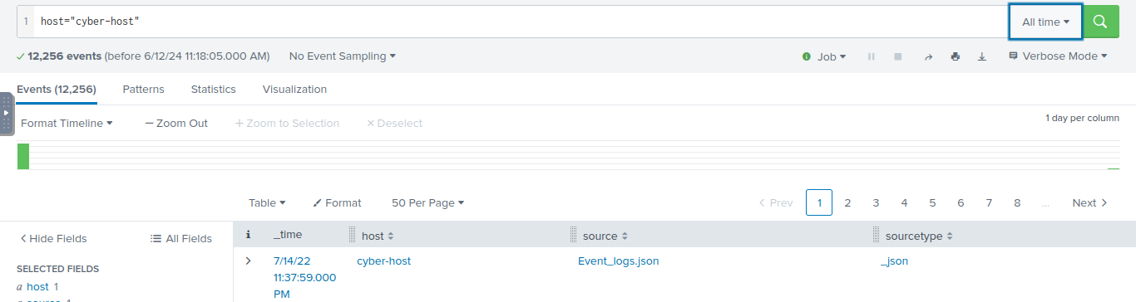

Working specifically on index = windows logs

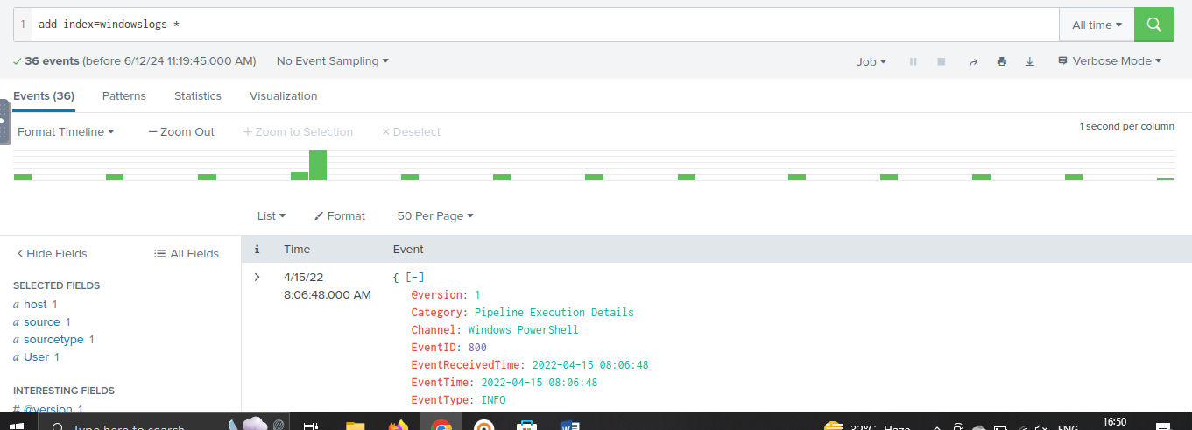

Searching for number of events during a time period between 8:05 am to 8:06 am on 4/15/2022.

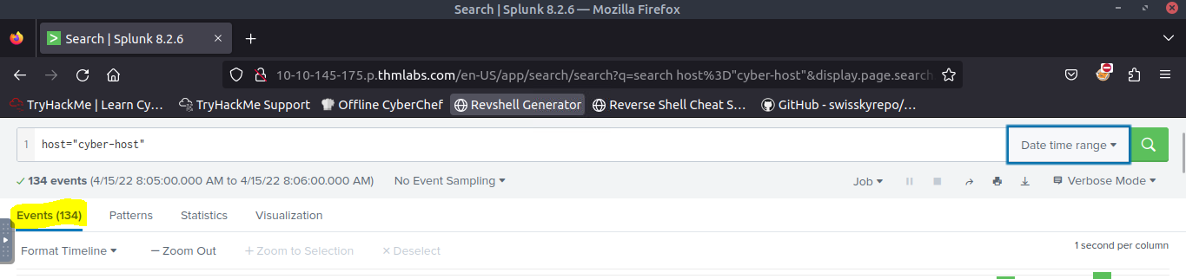

Using wildcard to search ips starting with 172

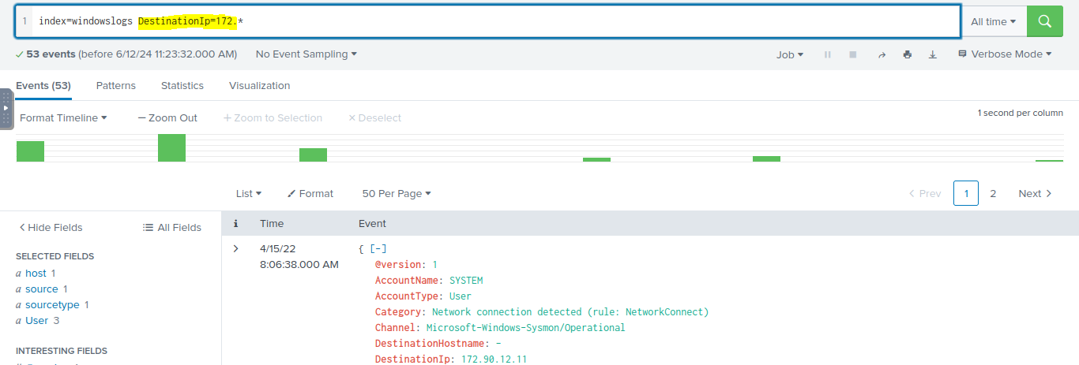

searching for Event ID 1 **AND** User as *James*

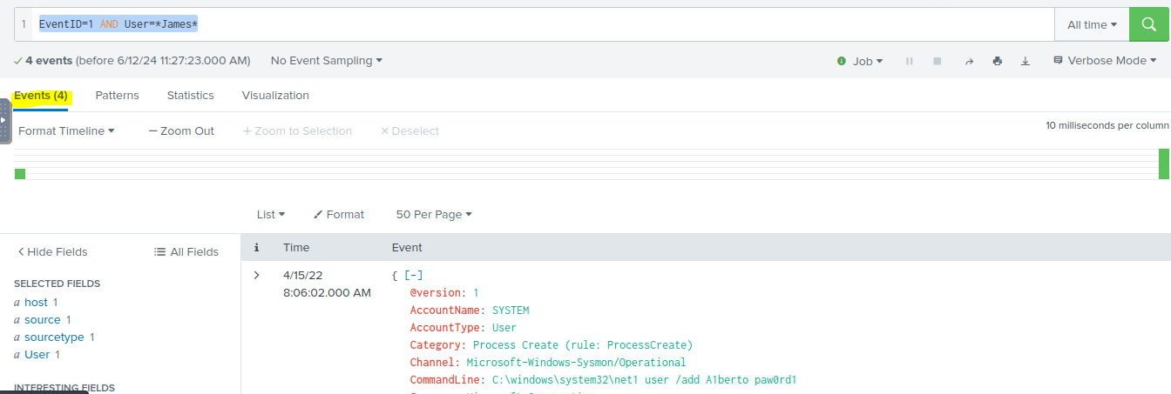

vents are observed with Destination IP 172.18.39.6 AND destination Port 135

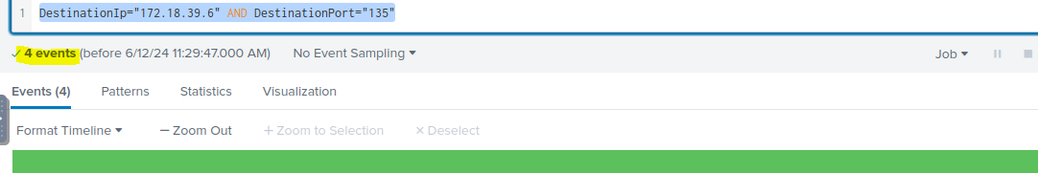

 index=windowslogs  Hostname="Salena.Adam" DestinationIp="172.18.38.5" . Which ip initiates more to the destination in this instance?

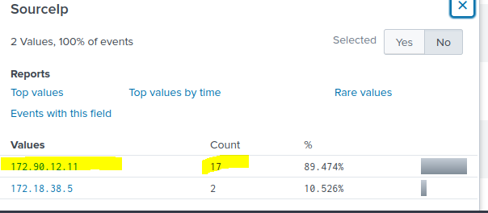

index=windowslogs | table _time EventID Hostname SourceName | reverse

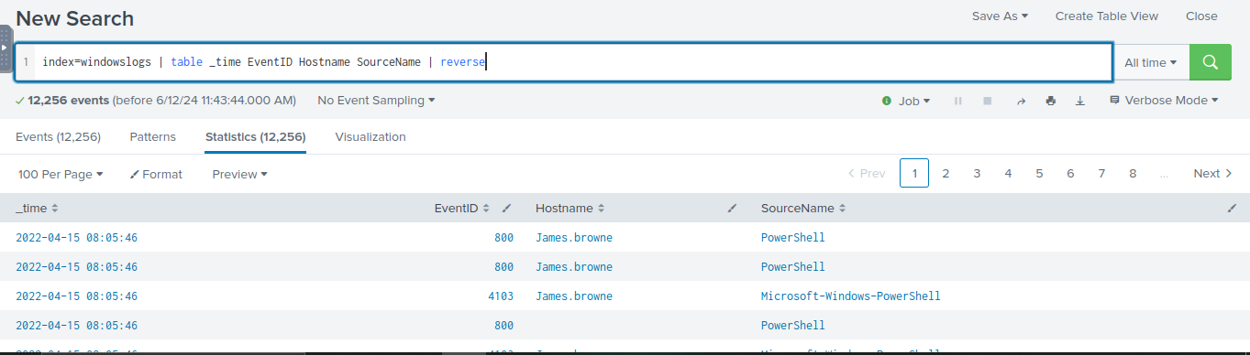

index=windowslogs | table _time EventID Hostname SourceName | dedup EventID | reverse

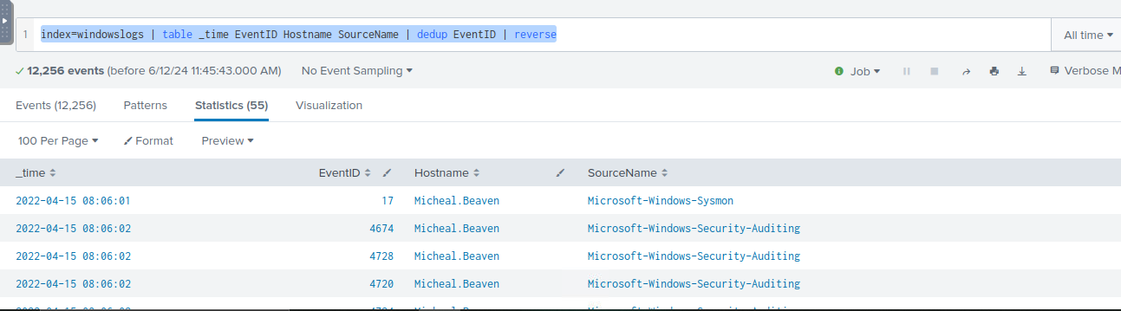

index=windowslogs | table _time EventID Hostname SourceName | dedup Hostname | reverse

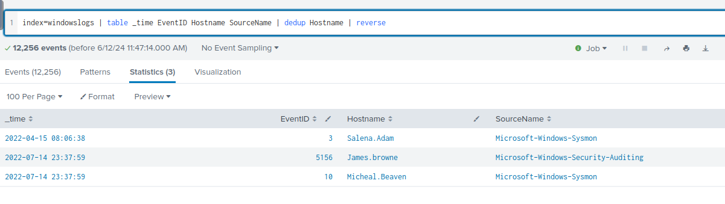

Reverse of the list and its host name

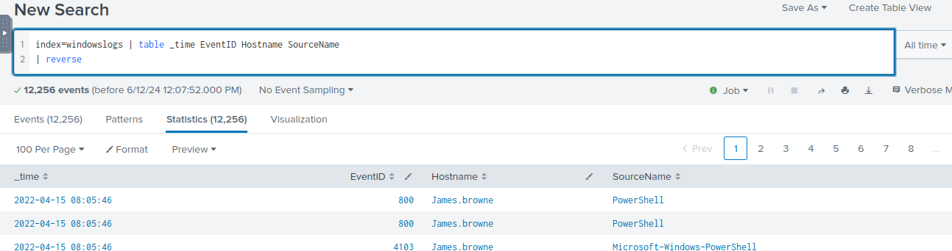

The top of the list when sorted.

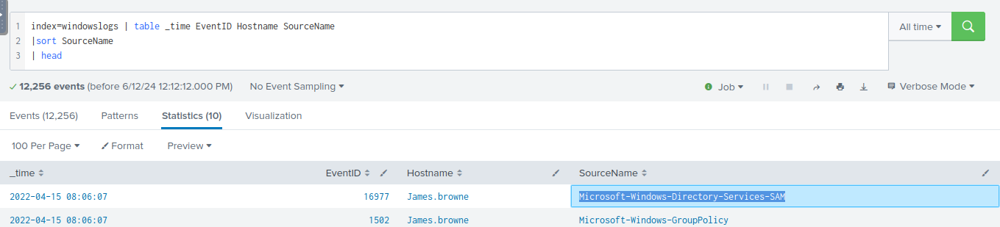

Total count of 6th image in the top 8 limit of the images

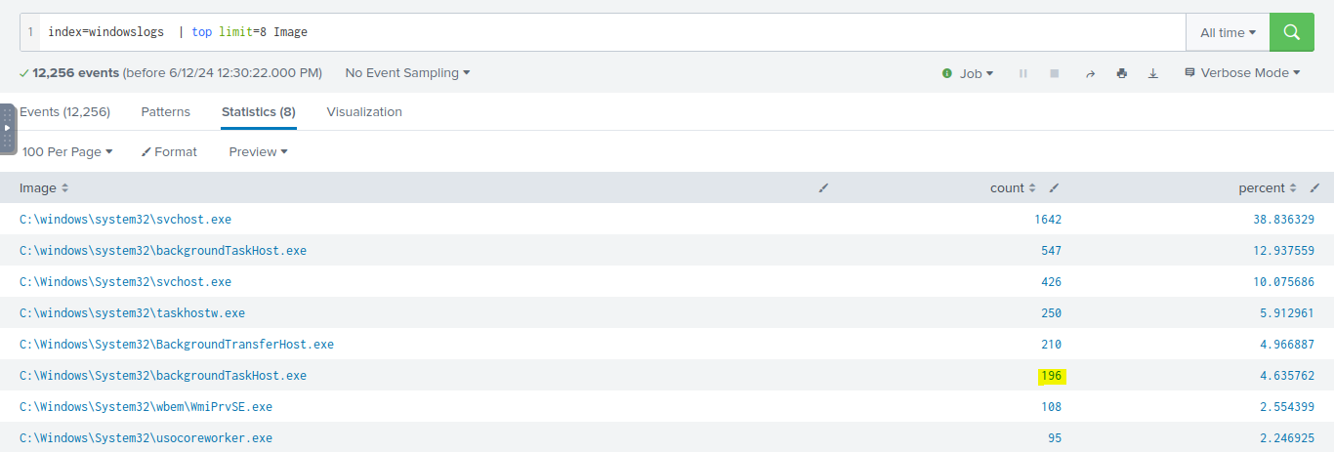

The user with the least number of activities

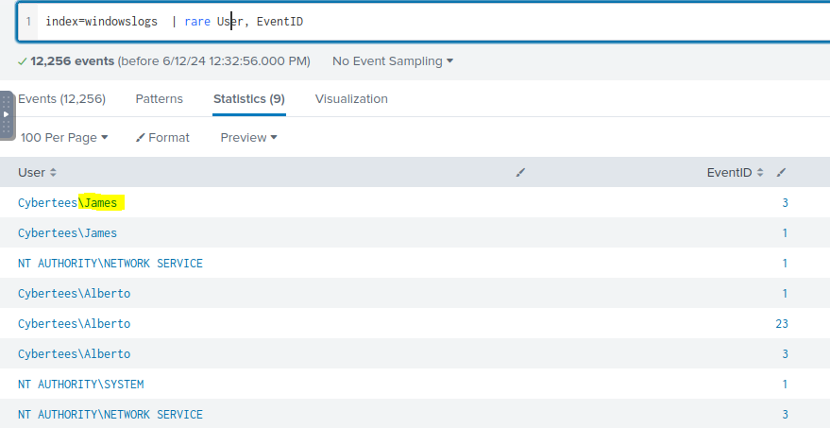

Piechart visualization

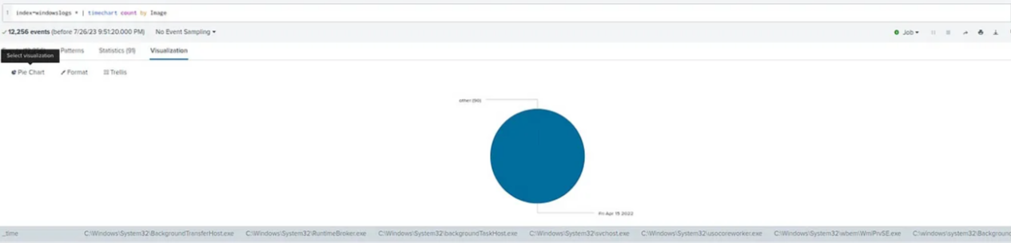

Rceiving data. Listening on port 9997

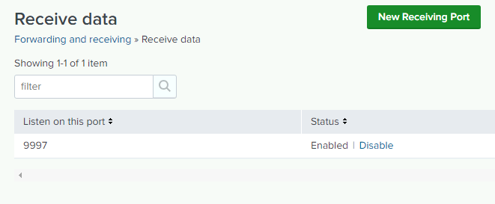

Indexes

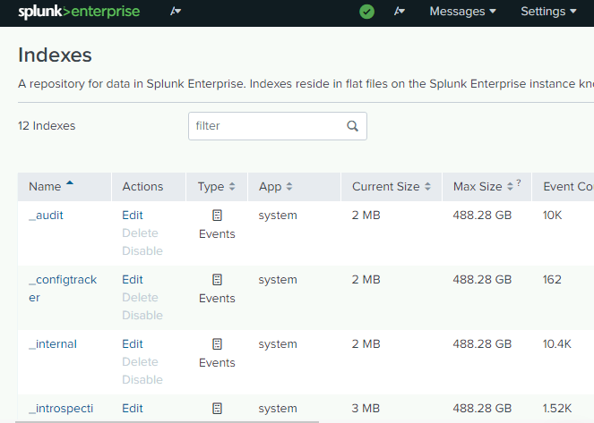

Forwarder management

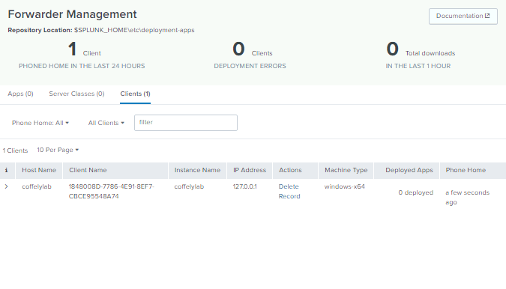

Configure forwarder

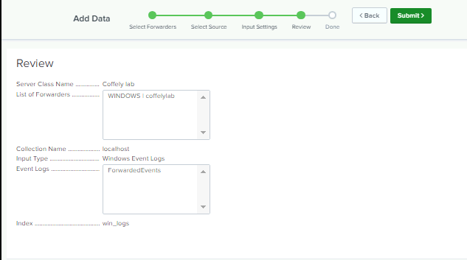

Weblog data

